**Assessment 4**

**Debugging**

**LIST OF BUGS FOUND:**

**B1.** Game does not pay out at correct level.

* When player wins on 1 match, balance does not increase

**B2.** Player cannot reach betting limit

* Limit set to 0, but game ends with player still with 5 (dollars) remaining

**B3.** Odds in the game do not appear to be correct

* Crown and Anchor games have an approximate 8% bias to the house. So the win : (win+lose) ratio should approximately equal 0.42. This does not appear to be the case.

**B4.** Same symbol is displayed on three dice in every turn.

**Solutions with Snapshots:**

**1. When player wins on 1 match, balance does not increase**

**Bug Found:**

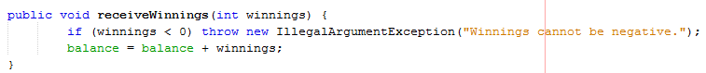

**Result:**

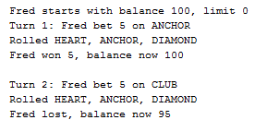

**Bug Resolved:**



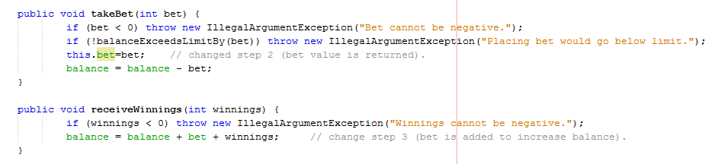

**Result:**

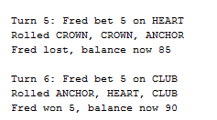

**2. Limit set to 0, but game ends with player still with 5 (dollars) remaining**

**Bug Found:**

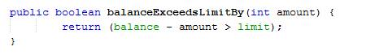

**Result:**

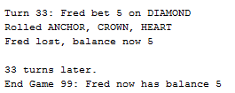

**Bug Resolved:**

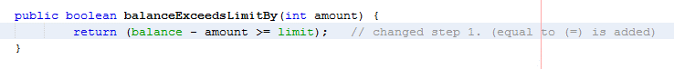

**Result:**

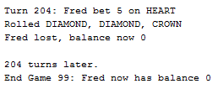

**3.** . **Odds in the game do not appear to be correct**

**Bug Found:**

**Result:**

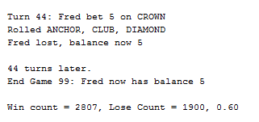

**Bug Resolved:**

**Result:**

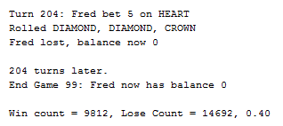

**4. Same symbol is displayed on three dice in every turn.**

**Bug Found:**

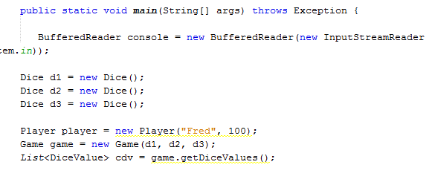

**Result:**

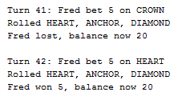

**Bug Resolved:**

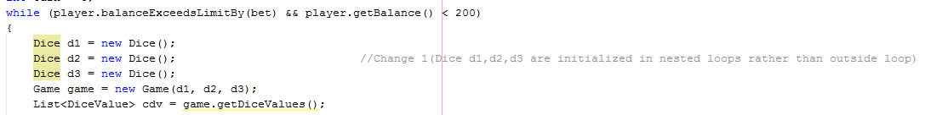

**Result:**

